Digital image Processing

**Assignment No 1**

**Report**

**Group Members:**

**Ghulam Hussain Khan Sherwani 366549**

**Abdul Basit Sajid 386804**

**Mohammad Irfan 373668**

Due Date: 27 - 09 - 2023

Submission Date: 27 - 09 - 2023

Submitted to: Muhammad Asad Khan

# Original Image:

# Task1:

## Resized Image:

Resized down image compared to the original size image (but in greyscale)

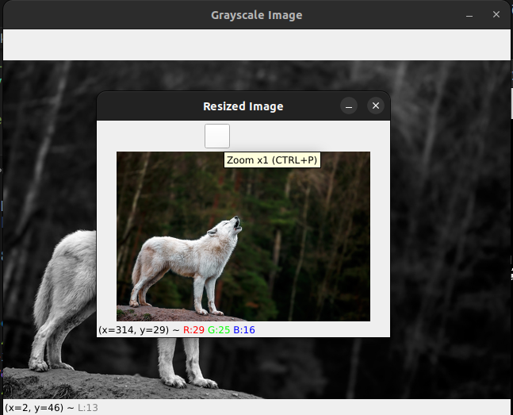

## 

# Task2:

## Gray Scale:

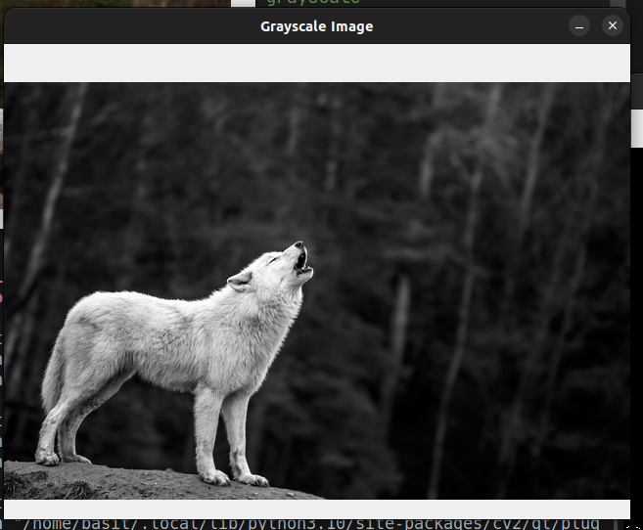

# Task3:

## Binary Image:

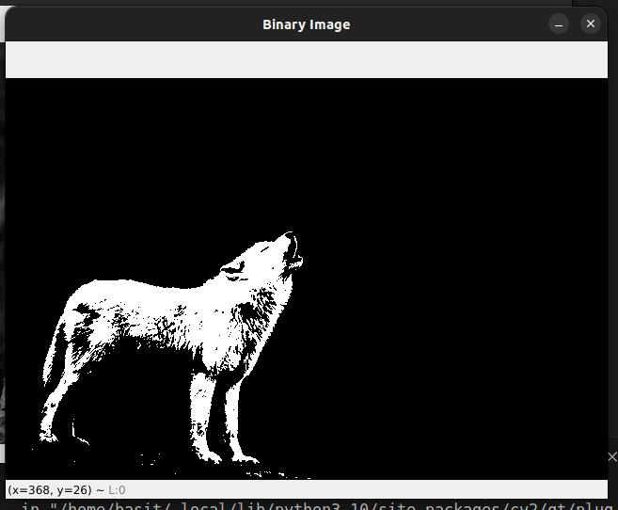

## Combined Code for above 3 tasks:

import cv2

# Load the RGB image

image = cv2.imread('./wolf.jpg')

# Convert the image to grayscale

gray_image = cv2.cvtColor(image, cv2.COLOR_BGR2GRAY)

# Threshold the grayscale image to create a binary image !! fine-tuned the threshold

_, binary_image = cv2.threshold(gray_image, 148, 255, cv2.THRESH_BINARY)

scaling_factor = 0.5 # Change this to own desired factor

# Resize the image while maintaining the aspect ratio

resized_image = cv2.resize(image, None, fx=scaling_factor, fy=scaling_factor)

# Save the resized image

cv2.imwrite('output.jpg', resized_image)

# Display the resized image (optional)

cv2.imshow('Resized Image', resized_image)

# Save the grayscale image

cv2.imwrite('gray_image.jpg', gray_image)

# Save the binary image

cv2.imwrite('binary_image.jpg', binary_image)

# Display the grayscale and binary images (optional)

cv2.imshow('Grayscale Image', gray_image)

cv2.imshow('Binary Image', binary_image)

# Wait for a key press and then close the windows

key=cv2.waitKey(0)

while key!=ord(" "):

key=cv2.waitKey(0)

cv2.destroyAllWindows()

# Task4:

## Count Coins:

No. of Coins in the image: 8



## Code:

import cv2

import numpy as np

image = cv2.imread('./coins.png')

gray_image = cv2.cvtColor(image, cv2.COLOR_BGR2GRAY)

#blur the image

blurred = cv2.GaussianBlur(gray_image, (15, 15), 0)

threshold_value = 155

# Apply binary thresholding

ret, binary_image = cv2.threshold(blurred, threshold_value, 255, cv2.THRESH_BINARY)

#invert the image

inverted_image = cv2.bitwise_not(binary_image)

# Find connected components in the inverted image

connectivity = 0 #

output = cv2.connectedComponentsWithStats(inverted_image, connectivity, cv2.CV_32S)

# Extract the connected components and their statistics

num_labels = output[0]

labels = output[1]

# Count the number of connected dark regions (islands)

num_of_coins = num_labels - 1 # Subtract 1 to exclude the background label

print(f"Number of coins: {num_of_coins}")

## Github Link:

<https://github.com/abd-ulbasit/digital-image-processing/tree/main/assignments/first>